**Exercise 4 -Company Registration**

**In the Workshops you learn about Arrays , Variable , Data Types , Structure , Loops ,Control statements and other various concepts of programming…From This ideas Create a console application to Register a company with following Fields.**

CompanyName,Email,Website,Phone,Location,Password

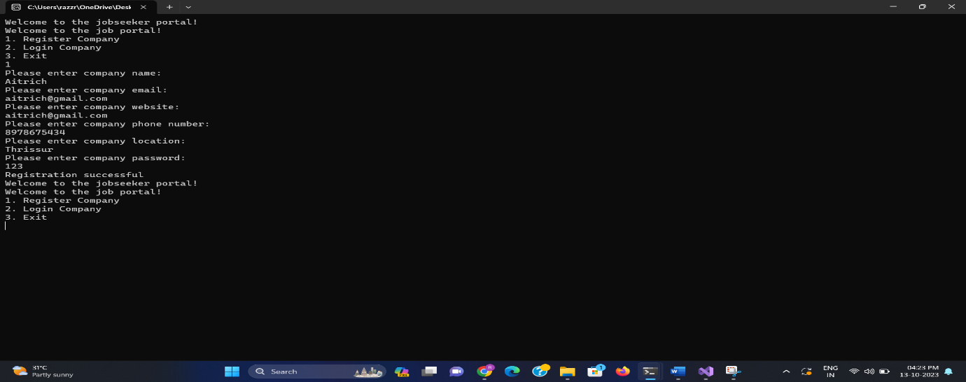

The registered company can Login with email and password .The Logged user have options to shedule interview , view sheduled interview list and logout option. This process will be repeated until logout option is choosen.

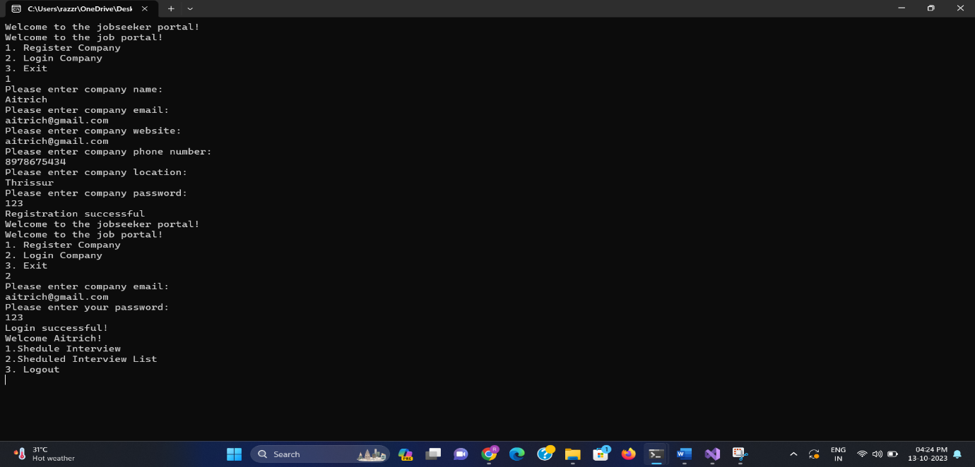

On choosing shedule interview You can able to schedule interview for the logged company with following fields..

Title,Date,Time,Location,CompanyName

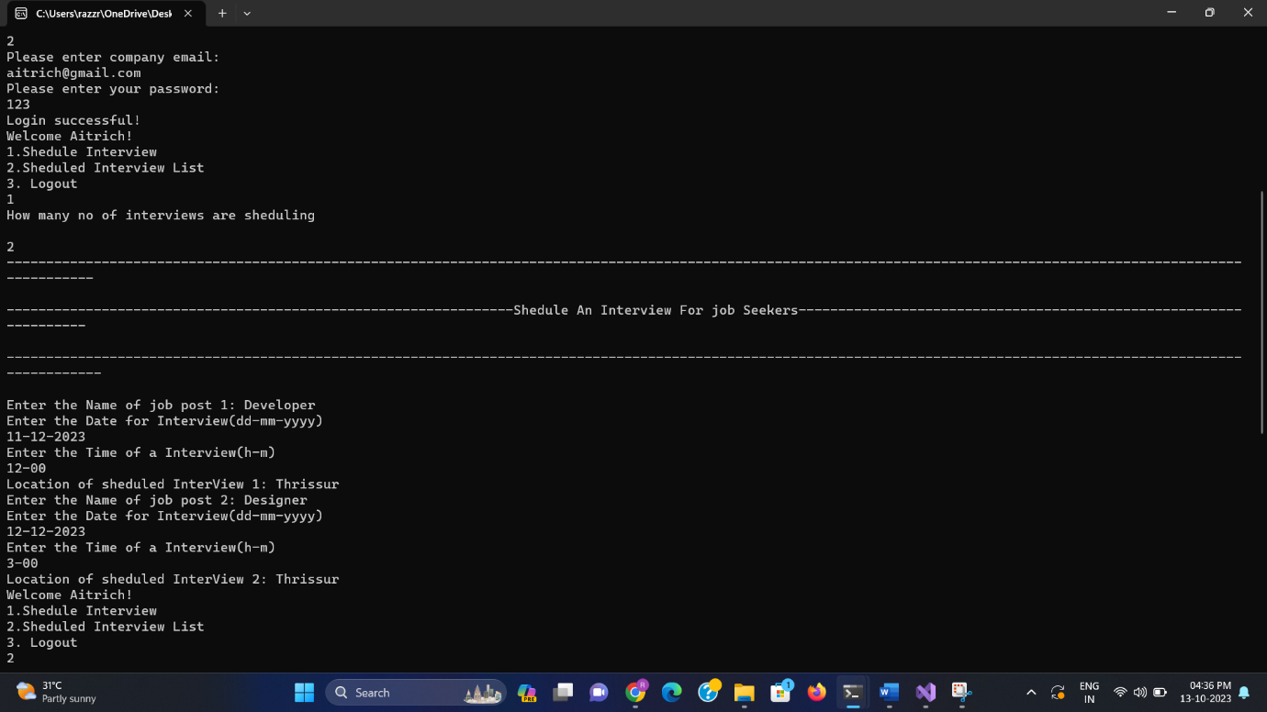

Ongoing to scheduled interview list option company list all interviews scheduled for that logged company..

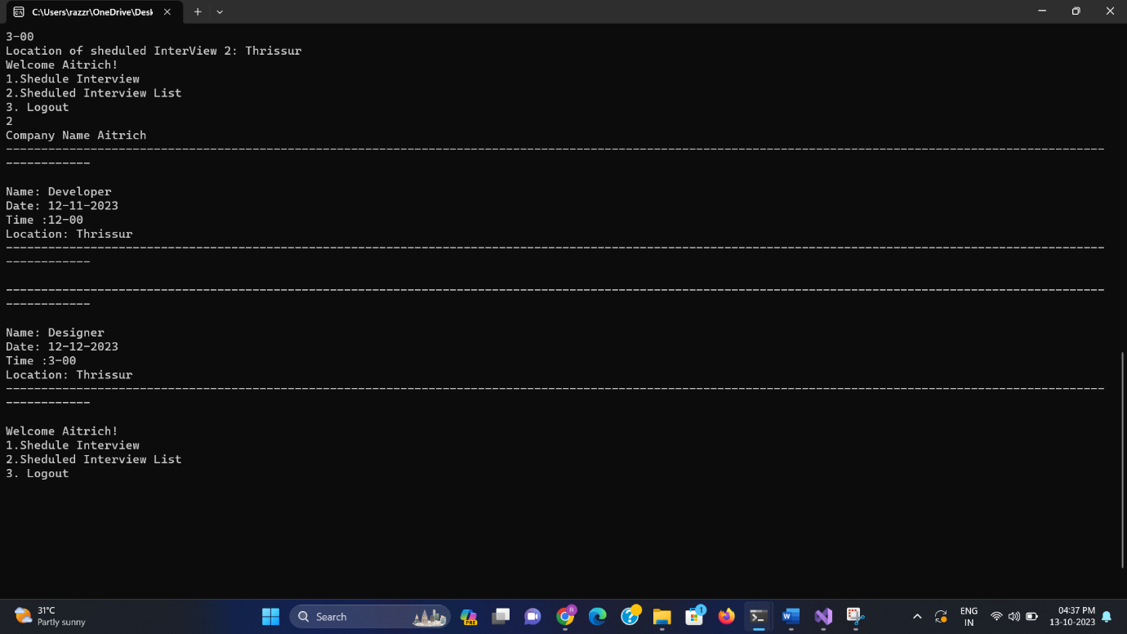

When user choose logout option user return back to the previous option

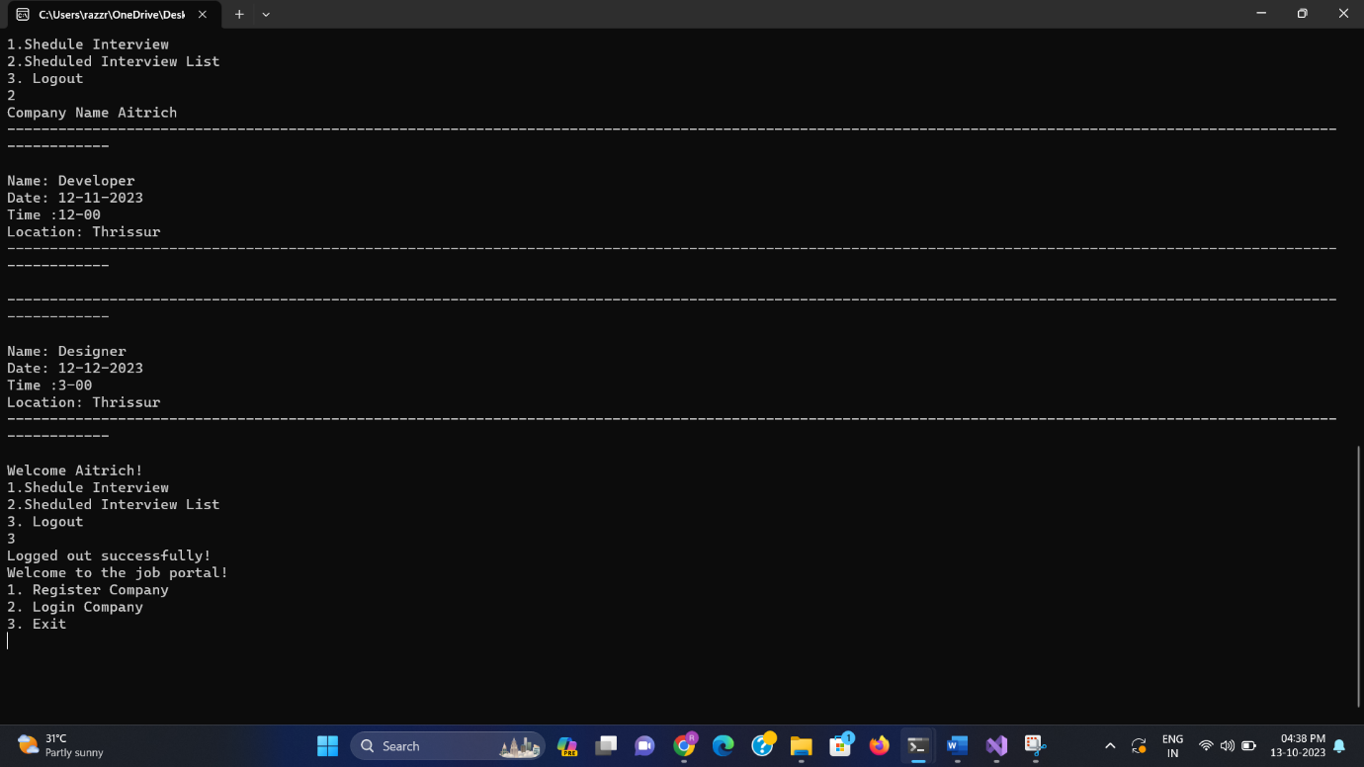

When user choose Exit option user will exit from the code…

After creating this console application add this application to the repository named Asp.NetCore C# in [**Aitrich-Academy**](https://github.com/Aitrich-Academy)  Organisation